**AI ASSITED CODING **

***Lab 7: Error Debugging with AI – Systematic Approaches to Finding and Fixing Bugs***

**#Task-1:**

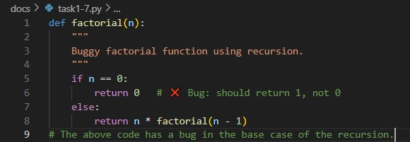**Prompt**: Introduce a buggy Python function that calculates the factorial of a number using recursion.

Use Copilot or Cursor AI to detect and fix the logical or syntax errors.

**Code Generated:**

**Observation:**

The first code contains a bug in the base case of the recursive factorial function. It incorrectly returns 0 when n == 0, which causes all recursive results to evaluate to zero. In contrast, the corrected version fixes the base case by returning 1 when n == 0, which is mathematically correct since 0! = 1. Apart from this change, both functions use the same recursive logic where n * factorial(n-1) computes the factorial. Thus, the main difference lies in handling the base case: the buggy code gives wrong outputs, while the corrected code produces accurate factorial values.

**#Task-2:**

**Prompt**: Provide a list sorting function that fails due to a type error (e.g., sorting list with mixed  
integers and strings).

Prompt AI to detect the issue and fix the code for consistent sorting.

**Observation:**

The first code (buggy_sort) tries to sort a list directly using sorted(lst), but it fails with a TypeError when the list contains mixed data types like integers and strings, since Python cannot compare them directly. The corrected code (fixed_sort) resolves this by using sorted(lst, key=str), which converts all elements to strings before comparison, ensuring consistent sorting without errors. While the buggy version highlights the limitation of sorting mixed types, the fixed version guarantees that sorting works smoothly, though it treats numbers as strings, meaning numeric order is lost in favour of lexicographic order.

**#Task-3:**

**Prompt:**Provide a piece of code with a ZeroDivisionError inside a loop

Ask AI to add error handling  
using try-except and continue execution safely.

**Observation:**

In the first code, the loop attempts to divide numbers in a list by 10, but when it encounters zero, a ZeroDivisionError occurs and the program crashes immediately, preventing further execution. In the corrected version, the risky division is wrapped in a try-except block, which catches the error when division by zero happens. Instead of stopping the program, it prints a warning message and safely continues with the remaining iterations. This makes the corrected code more robust and reliable, as it gracefully handles errors without interrupting execution.

#**Task-4:**

**Prompt:**

Write a Python snippet for file handling that opens a file but forgets

to close it

Ask Copilot or Cursor AI to improve it using the best practice (e.g., with open() block).

**Observation:**

In the first code, the file is opened using open("sample.txt", "r") but never explicitly closed, which can cause issues like memory leaks or file locks if used repeatedly. The improved version suggested by Copilot uses the with open() context manager, which ensures that the file is automatically closed once the block is exited, even if an error occurs. This makes the code more reliable, safer, and a best practice in Python file handling compared to the manual open-and-forget approach of the first version.

**#Task-5:**

**Prompt:** Include a buggy class definition with incorrect __init__ parameters or attribute references

Ask AI to analyze and correct the constructor and attribute usage.

**Observation:**

In the first code, the class definition is buggy because the constructor __init__ is missing the required self-parameter, and the attributes are referenced using self even though it was never defined, which causes errors when creating objects. Additionally, the display method does not include self as a parameter, so it cannot access instance attributes. In the corrected version, Copilot adds self to both the constructor and the method, ensuring that instance variables name and age are properly initialized and accessed. This makes the class functional, allowing objects to be created and their details displayed without errors.